ST. CATHERINE HIGH SCHOOL SUBJECT: FOOD NUTRITION AND HEALTH
TOPIC: CONVENIENCE FOODS

INSTRUCTIONS TO STUDENTS:
With use of prescribed texts and other available resources read and complete the worksheet.

Objectives:
At the end of the lesson students should be able to:

- Define the term convenience foods.
- Outline the common reasons for the popularity of convenience foods.
- Discuss the dietary advantages and disadvantages (dangers) of convenience foods.
- Categorize convenience foods with appropriate examples.
- Utilize convenience food items to create or make nourishing meal choices.

What Are Convenience Food items?
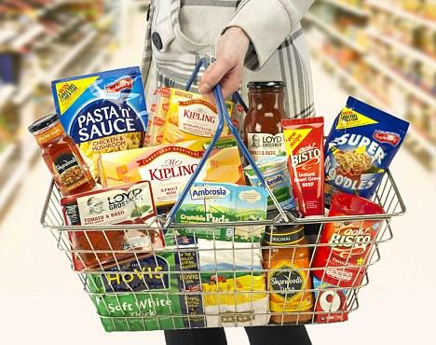
Convenience Food items are foods that are fully or partly processed to make them ready to consume or require minimal effort and time to prepare.

Reasons for the popularity of convenience foods:
1. Many parents especially women are in the workforce, leaving less time for traditional cooking.
2. The impact of globalization and advertising on food choices.

Other reasons include:
3. ………………………………………………………………………………………………..
4. ………………………………………………………………………………………………..

Advantages of using convenience foods:
1. Quick and easier to prepare or no preparation needed.
2. A wide variety is available for consumers
Other advantages of using convenience foods are:
3. ………………………………………………………………………………………………..
4. ………………………………………………………………………………………………..
5. ……………………………………………………………………………………………….
Disadvantages of using convenience foods:
1. They are normally high in salt, sugar and or fats.
2. The portions tend to be small in comparison with the cost.
Other disadvantages of using convenience foods are:
3. ………………………………………………………………………………………………..
4. ………………………………………………………………………………………………
5. ………………………………………………………………………………………………..

Categories of Convenience Foods with examples (from Text: Food and Nutrition for CSCE, Anita Tulland Antonia Coward )

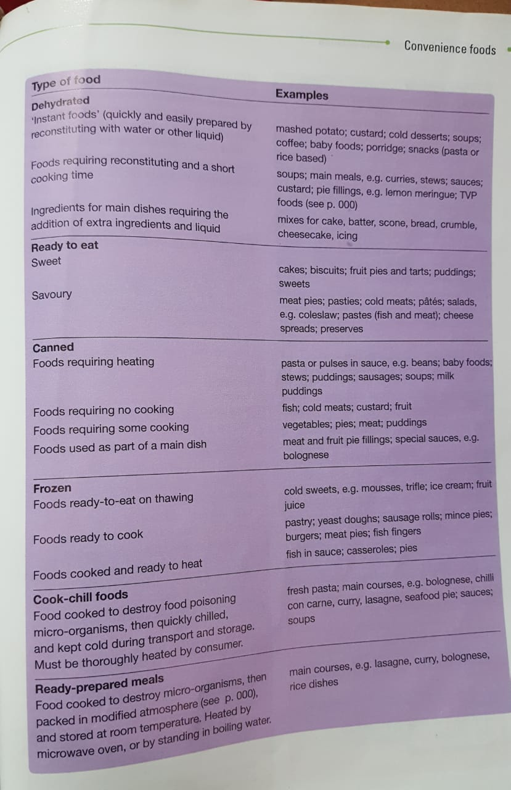

Using Convenience Food items to Create Nourishing Meal Options

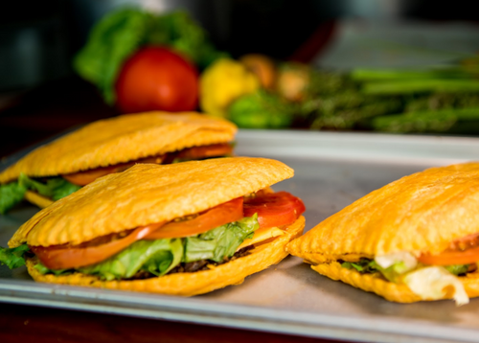

Convenience Food items | Use of Convenience Food items in  nourishing Ways.
Eg. Beef Patty | Beef Patty served with Tossed Vegetable bowl and fresh fruit juice.
Eg. Cup Noodle | Chicken breast with vegetables and noodle stir fry.
1. Potato Flakes
2. Sausages/Frankfurters
3. Cheese Singles
4. Frozen Fruits
5. Frozen or canned Vegetables
6. Refined Cornmeal
7. Coconut Milk Powder

Main Source Food and Nutrition for CSEC (Anita Tull and Antonia Coward)

