Grade:11 Human & Social Biology

REPRODUCTION in HUMANS

Specific objectives:

7.1 distinguish between sexual and asexual - reproduction;

7.2 describe the structure and function of the reproductive systems in human beings; Include the structures of the gametes, diagram of systems required; related disorders such as ovarian, cervical and prostate cancers.

7.3 describe the menstrual cycle; Use of diagram for illustration; include role of hormones: follicle stimulating hormone (FSH), luteinising hormone (LH), oestrogen, progesterone.

7.4 explain ovulation, fertilisation: Diagram of foetus in uterus required; role of placenta, implantation and development of the umbilical cord and amniotic sac; minute details of embryo; stages of development are not required.

7.5 describe the birth process; outline the THREE stages of labour

7.6 outline the importance of prenatal care; Importance of ante-natal and post-natal care including the advantages of breastfeeding.

7.7 explain how birth control methods prevent pregnancy: Natural, barrier, hormonal and surgical.

7.8 explain the advantages and disadvantages of birth control methods; Include the use of condoms to prevent STIs.
7.9 discuss the issues related to abortion; Include reasons for; spontaneous abortion (miscarriage); advantages and disadvantages of abortion.

7.10 explain the importance of family planning; Social and economic implications.

CONTENT:

One parent or two?
That is the main difference between sexual and asexual reproduction. Sexual reproduction just means combining genetic material from two parents. Asexual reproduction produces offspring genetically identical to the one parent using one parent.

Reproduction: Asexual vs. Sexual
Cell division is how organisms grow and repair themselves. It is also how many organisms produce offspring. For many single-celled organisms, reproduction is a similar process. The parent cell simply divides to form two daughter cells that are identical to the parent. In many other organisms, two parents are involved, and the offspring are not identical to the parents. In fact, each offspring is unique. Look at the family in Figure below. The children resemble their parents, but they are not identical to them. Instead, each has a unique combination of characteristics inherited from both parents.
Family Portrait: Mother, Daughter, Father, and Son. Children resemble their parents, but they are never identical to them. Do you know why this is the case?[Figure2]
Reproduction is the process by which organisms give rise to offspring. It is one of the defining characteristics of living things. There are two basic types of reproduction: asexual reproduction and sexual reproduction.

Asexual Reproduction
Asexual reproduction involves a single parent. It results in offspring that are genetically identical to each other and to the parent. All prokaryotes and some eukaryotes reproduce this way. There are several different methods of asexual reproduction. They include binary fission, fragmentation, and budding.
- Binary fission occurs when a parent cell splits into two identical daughter cells of the same size.
- Fragmentation occurs when a parent organism breaks into fragments, or pieces, and each fragment develops into a new organism. Starfish, like the one in Figure below, reproduce this way. A new starfish can develop from a single ray, or arm. Starfish, however, are also capable of sexual reproduction.
- Budding occurs when a parent cell forms a bubble-like bud. The bud stays attached to the parent cell while it grows and develops. When the bud is fully developed, it breaks away from the parent cell and forms a new organism. Budding in yeast is shown in Figure below.
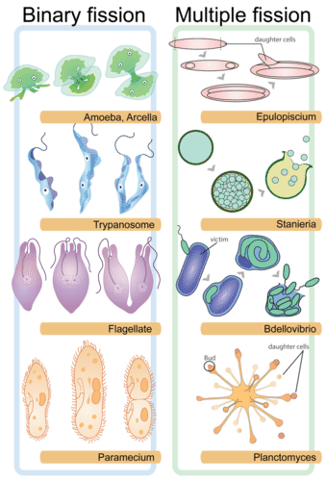
Binary Fission in various single-celled organisms (left). Cell division is a relatively simple process in many single-celled organisms. Eventually the parent cell will pinch apart to form two identical daughter cells. In multiple fission (right), a multinucleated cell can divide to form more than one daughter cell. Multiple fission is more often observed among protists.[Figure3]
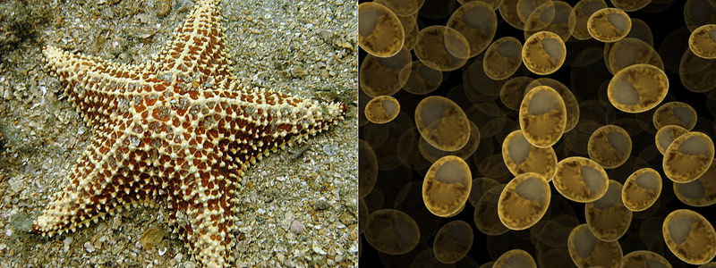
Starfish reproduce by fragmentation and yeasts reproduce by budding. Both are types of asexual reproduction.[Figure4]
Asexual reproduction can be very rapid. This is an advantage for many organisms. It allows them to crowd out other organisms that reproduce more slowly. Bacteria, for example, may divide several times per hour. Under ideal conditions, 100 bacteria can divide to produce millions of bacterial cells in just a few hours! However, most bacteria do not live under ideal conditions. If they did, the entire surface of the planet would soon be covered with them. Instead, their reproduction is kept in check by limited resources, predators, and their own wastes. This is true of most other organisms as well.

Sexual Reproduction
Sexual reproduction involves two parents. As you can see from Figure below, in sexual reproduction, parents produce reproductive cells—called gametes—that unite to form an offspring. Gametes are haploid cells. This means they contain only half the number of chromosomes found in other cells of the organism. Gametes are produced by a type of cell division called meiosis, which is described in detail in a subsequent concept. The process in which two gametes unite is called fertilization. The fertilized cell that results is referred to as a zygote. A zygote is diploid cell, which means that it has twice the number of chromosomes as a gamete.
Symbols showing gender ( male and female)
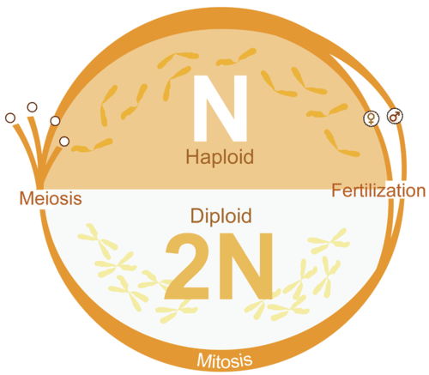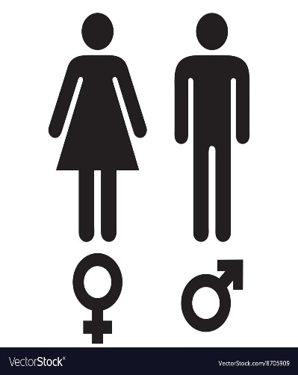

Male gamete/ sperm

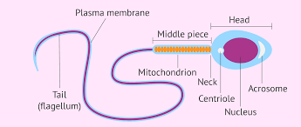

Female gamete/ ovum or egg
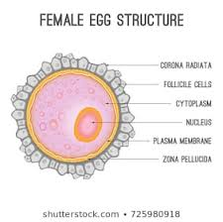

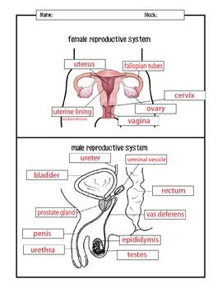Female Reproductive System (functions)

The female reproductive system is comprised of both internal and external reproductive organs that both enable fertilization and support embryonic development. Structures of the female reproductive system include:
- ﻿Labia majora: Larger lip-like external structures that cover and protect other reproductive structures.
- Labia minora: Smaller lip-like external structures found inside the labia majora. They provide protection to the clitoris, urethra, and vaginal openings.
- Clitoris: Sensitive sexual organ located in the uppermost section of the vaginal opening. The clitoris contains thousands of sensory nerve endings that respond to sexual stimulation and promote vaginal lubrication.
- Vagina: Fibrous, muscular canal leading from the cervix to the external portion of the genital canal. The penis enters the vagina during sexual intercourse.
- Cervix: Opening of the uterus. This strong, narrow structure expands to allow sperm to flow from the vagina into the uterus.
- Uterus: Internal organ that houses and nurtures female gametes after fertilization, commonly called the womb. A placenta, which encases a growing embryo, develops and attaches itself to the uterine wall during pregnancy. An umbilical cord stretches from the fetus to its placenta to provide nutrients from a mother to an unborn baby.
- Fallopian tubes: Uterine tubes that transport egg cells from the ovaries to the uterus. Fertile eggs are released from ovaries into fallopian tubes during ovulation and typically fertilized from there.
- Ovaries: Primary reproductive structures that produce female gametes (eggs) and sex hormones. There is one ovary on either side of the uterus.

Male Reproductive System (functions)

Encyclopaedia Britannica/UIG/Getty Images
The male reproductive system consists of sexual organs, accessory glands, and a series of duct systems that provide a pathway for sperm cells to exit the body and fertilize an egg. Male genitalia only equips an organism to initiate fertilization and does not support the development of a growing fetus. Male sex organs include:
- Penis: The main organ involved in sexual intercourse. This organ is composed of erectile tissue, connective tissue, and skin. The urethra stretches the length of the penis and allows either urine or sperm to pass through its external opening.
- Testes: Male primary reproductive structures that produce male gametes (sperm) and sex hormones. Testes are also called testicles.
- Scrotum: External pouch of skin that contains the testes. Because the scrotum is located outside of the abdomen, it can reach temperatures that are lower than that of internal body structures. Lower temperatures are necessary for proper sperm development.
- Epididymis: System of ducts that receive immature sperm from the testes. The epididymis functions to develop immature sperm and house mature sperm.
- Ductus Deferens or Vas Deferens: Fibrous, muscular tubes that are continuous with the epididymis and provide a pathway for sperm to travel from the epididymis to the urethra
- Urethra: Tube that extends from the urinary bladder through the penis. This canal allows for the excretion of reproductive fluids (semen) and urine from the body. Sphincters prevent urine from entering the urethra while semen is passing through.
- Seminal Vesicles: Glands that produce fluid to nurture and provide energy to sperm cells. Tubes leading from the seminal vesicles join the ductus deferens to form the ejaculatory duct.
- Ejaculatory Duct: Duct formed from the union of the ductus deferens and seminal vesicles. Each ejaculatory duct empties into the urethra.
- Prostate Gland: Gland that produces a milky, alkaline fluid that increases sperm motility. The contents of the prostate empty into the urethra.
- Bulbourethral or Cowper's Glands: Small glands located at the base of the penis. In response to sexual stimulation, these glands secrete an alkaline fluid which helps to neutralize acidity from the vagina and urine in the urethra.

