ST CATHERINE HIGH SCHOOL APRIL 2020

BIOLOGY
GENETICS GRADE 11
TEACHER ; MR S. HANSEL

THE CELL CYCLE- MITOSIS
A cell cycle is a series of events that takes place in a cell as it grows and divides. A cell spends most of its time in what is called interphase, and during this time it grows, replicates its chromosomes, and prepares for cell division. The cell then leaves interphase, undergoes mitosis, and completes its division.
Cell cycle is the name we give the process through which cells replicate and make two new cells. Cell cycle has different stages called G1, S, G2, and M. G1 is the stage where the cell is preparing to divide. To do this, it then moves into the S phase where the cell copies the entire DNA. So, S stands for DNA synthesis. After the DNA is copied and there's a complete extra set of all the genetic material, the cell moves into the G2 stage, where it organizes and condenses the genetic material, or starts to condense the genetic material, and prepares to divide. The next stage is M. M stands for mitosis. This is where the cell actually partitions the two copies of the genetic material into the two daughter cells. After M phase completes, cell division occurs and two cells are left, and the cell cycle can begin again.

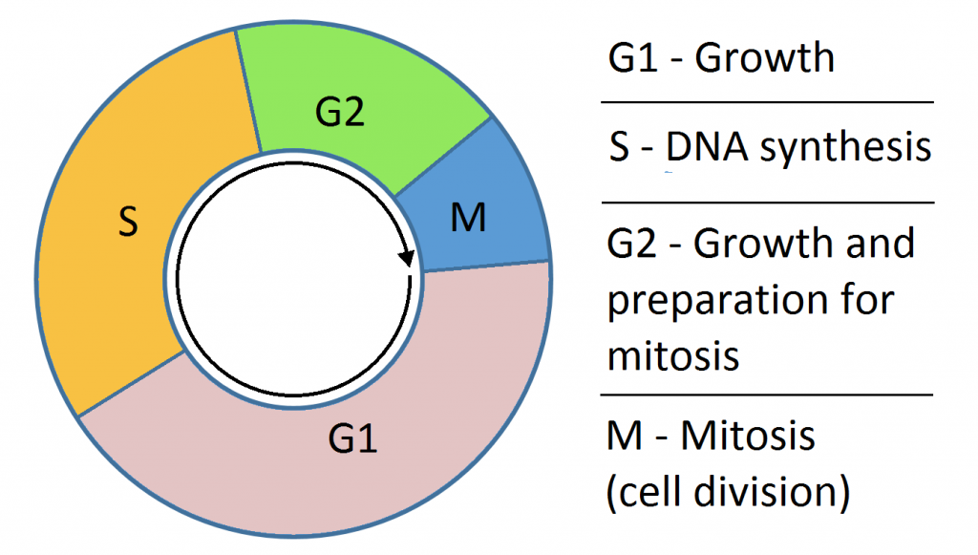

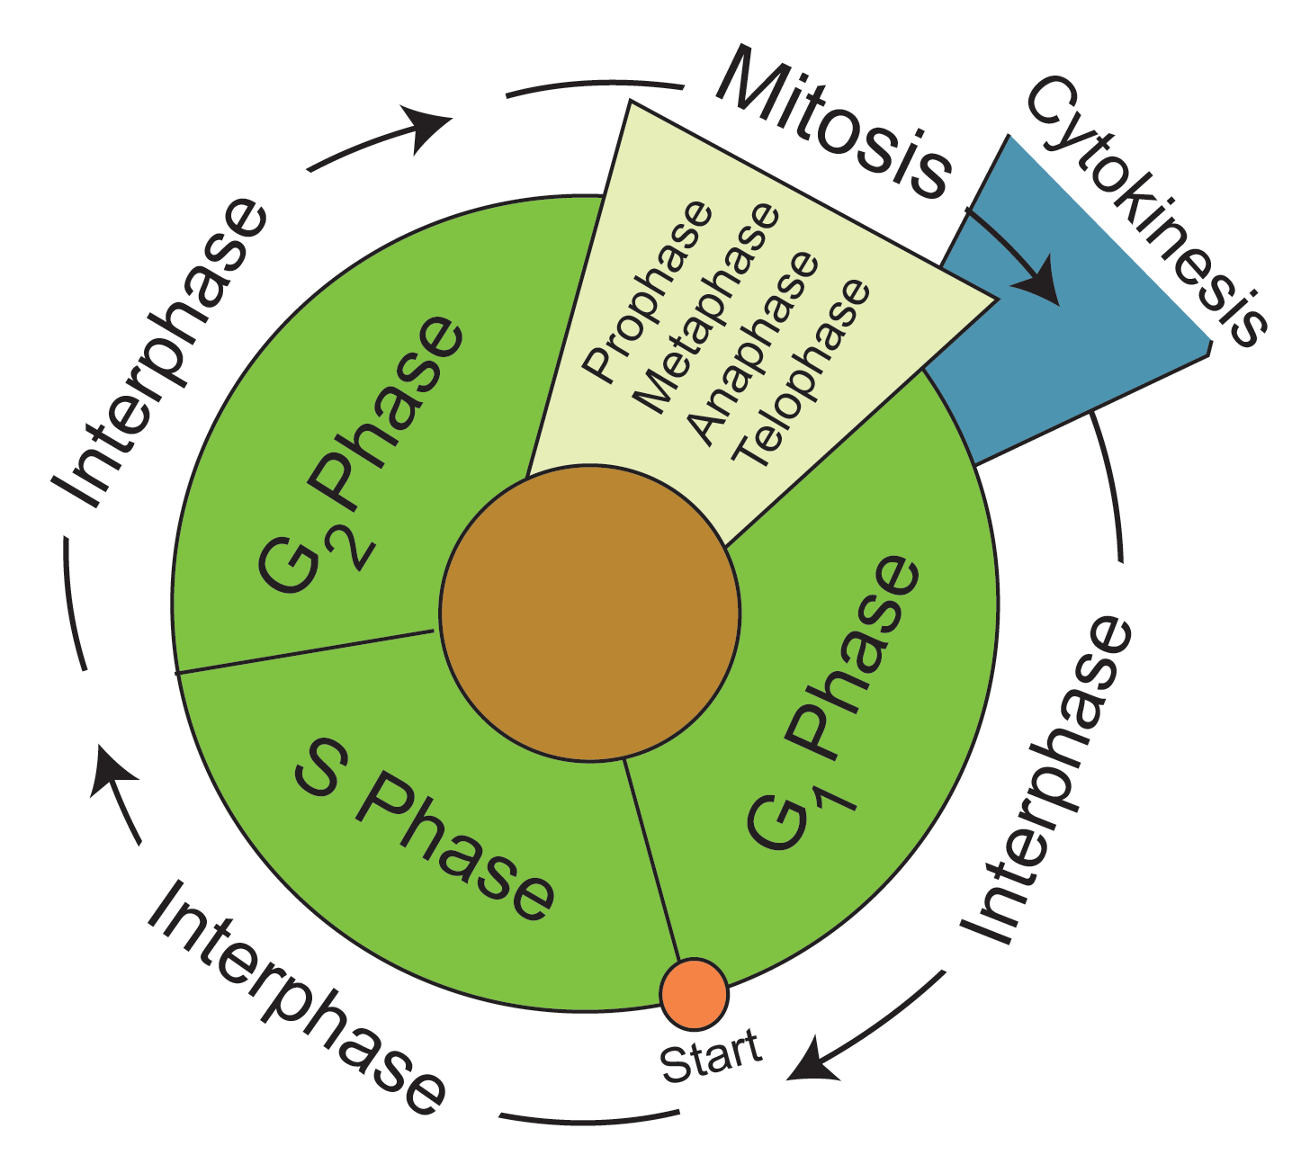

Definition of terms used in explanation of Mitosis
For you to easily understand the process of mitosis there is need to explain some terms used in the description of this process.
- Daughter cells in mitosis: Daughter cells in mitosis refer to the cells that are formed from the parent cell. A parent cell is a single cell that will divide itself into two to form the daughter cells. Please note that after mitosis you have two cells from a single cell it is not as if the parent cell is different from the two daughter cells formed; it is as if you cut a single orange to form two equal halves and the equal halves now are called daughter cells.
- Chromatids: Chromatids are the strands of replicated chromosomes that become the chromosomes when they contract
- Microtubules: Microtubules are support fibers for movement of chromosomes during mitosis
- Centromeres: Centromeres are needed for the separation of chromatids during mitosis and they are visible as constrictions which serve as sites of attachment of spindle microtubules.

Functions of mitosis
- Mitosis helps in growth: when the fusion of spermatozoon and ovum occurs, they form a zygote which then starts growing to form a human being or a baby of any animal that has many cells (multicellular organisms). The organisms or human beings grow by the process of mitosis occurring in different parts of the body
- Mitosis helps in replacement of cells and tissue repair: friction occurs as our bodies come in contact with others or hard surfaces and this causes damage to the skin and other parts of the body; even when we eat, some parts of the intestines slough off and even when we urinate, the urinary tract slough off. There is need for the body to replace this damaged parts of the body or repair the worn out body tissues; the body does this by sending signal to the cell concerned to start cell division and mitosis. In fact in some animals, the whole part of the body can be regenerated such as the starfish regenerating a whole arm.
- Mitosis also functions in asexual reproduction: mitosis is the basis of asexual reproduction by unicellular organisms and also the basis of cloning in biotechnology. Budding in multicellular organisms is a form of asexual reproduction and the unicellular organism such as amoeba also reproduces asexually; all these occur by mitosis.
- Mitosis functions in immune response: mitosis helps in the cloning of B-lymphocytes and T-lymphocytes during the immune response.

Where does mitosis occur?
Mitosis occurs in almost all cells of the body with the exception of the cardiac tissue and nerve tissues (these two tissues do not undergo mitosis because they remain dormant in the G0 phase of cell cycle). The process of mitosis occurs inside the nucleus of dividing cells.
Some body tissues take a longer period of time before the cells divide while others take a shorter time and still others do not even divide at all. Epithelial tissues such as that of the intestines and that of the skin undergo mitosis within a short period of time (there is rapid cell turnover) this is the reason why an injury to the mouth or skin heals faster than muscles or any other tissue. Tissues such as Nerves and cardiac muscles do not divide and this explains why a damaged nerve cannot be repaired again and permanent paralysis of the muscle supplied by the nerve occurs such as in paralysis caused by poliomyelitis. It is also the same reason why heart attack following ischemia leads to heart failure because the heart muscles cannot divide to form new ones again.

Mitosis stages
- Prophase (the first stage of mitosis)
- Metaphase (the second stage of mitosis)
- Anaphase (the third stage of mitosis)
- Telophase (the fourth and last stage of mitosis)
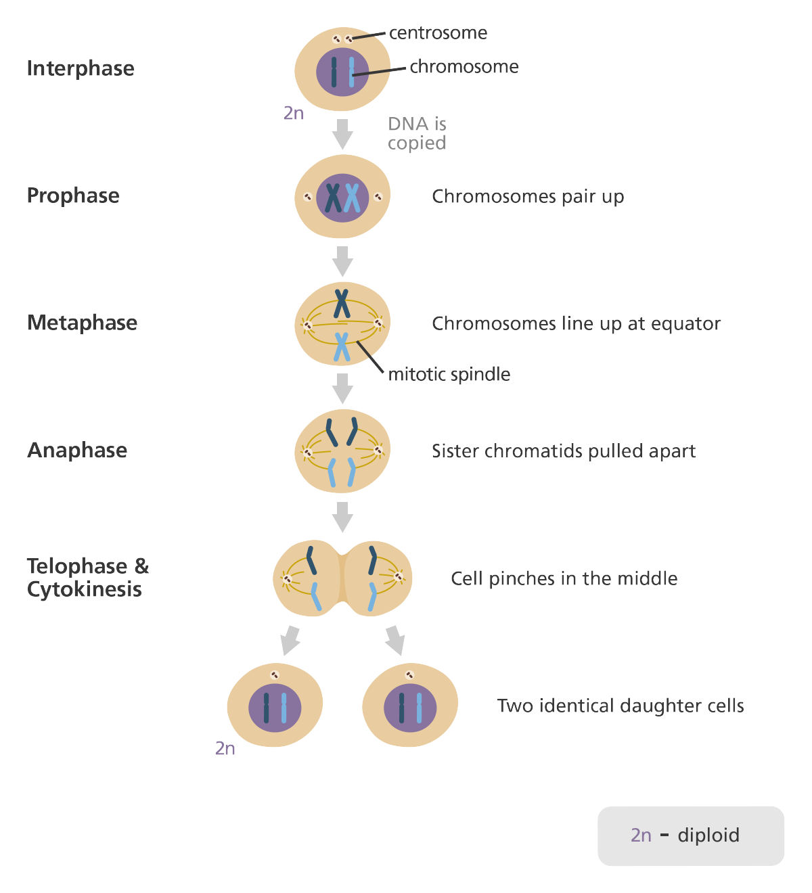
Prophase stage of Mitosis: the centrosomes begin to move to opposite poles
What is prophase?
Mitosis begins with prophase (it is the first stage of mitosis) and it is the longest phase of mitosis. In order for prophase to start, several events must occur to enable access to the chromosomes in the nucleus such as the breaking of the nuclear envelope into small vesicles, the Golgi apparatus and endoplasmic reticulum fragment and disperse to the periphery of the cell while the nucleolus disappears.

What happens in prophase?
- The centrosomes begin to move to opposite poles of the cell.
- The microtubules that form the basis of the mitotic spindle extend between the centrosomes, pushing them farther apart as the microtubule fibers lengthen.
- The sister chromatids (joined by cohesins) begin to coil more tightly and become visible under a light microscope
- At the centromere region of each chromosome, a large protein complex called the kinetochore serves as a site for attachment to microtubules.
- Late in prophase, lamins and inner nuclear membrane are phosphorylated, causing the nuclear lamina and nuclear pore complexes to disassemble and disperse in cytoplasmic membrane vesicles
Metaphase stage of mitosis: the chromosomes condense and move to the centre

Prometaphase
This is not a major stage of mitosis as it occurs briefly before metaphase. In this stage, the chromosomes attach to spindle microtubules at their kinetochores and begin to be moved.

Metaphase of mitosis (What happens in Metaphase?)
- During metaphase, the chromosomes condense further and attach to the mitotic spindle at large electron-dense protein complexes called kinetochores at each centromere
- The cell is now more spherical and the chromosomes are moved to align at its center (equatorial plane)

Anaphase stage of Mitosis: the chromosomes move to the poles

Anaphase of mitosis (What happens in Anaphase?)
- Sister chromatids (now called chromosomes) separate from each other to become individual chromosomes that are pulled toward the spindle poles.
- The poles move apart and the kinetochore microtubules get shorter
Telophase stage of Mitosis: the chromosomes begin reverting and the nuclear envelope begin to reassemble

Telophase stage of Mitosis (What happens in telophase?)
- The two sets of chromosomes are at the spindle poles and begin reverting to their decondensed state
- The spindle depolymerizes and the nuclear envelope begins to reassemble around each set of daughter chromosomes
- A belt-like contractile ring of actin filaments associated with myosins develops in the peripheral cytoplasm at the cells equator.
- During cytokinesis (at the end of telophase), constriction of the ring produces a cleavage furrow and progresses until the cytoplasm and its organelles are divided into two daughter cells, each with one nucleus

ACTIVITY
  - a ) Explain why plants why produced from the seeds of the tomato plant are NOT identical to the parent plant 2 marks ( CSEC JAN 2013)
b) Suggest TWO advantages that may be gained by propagating this plant asexually ,for example ,by tissue culture. ,2 marks (CSEC JAN 2013)

c)Suggest TWO characteristics that a farmer may want to keep in his crop of tomato plant. 2 marks (CSEC JAN 2013)

