Physical Education
Grades 7, 8 & 9 Girls
March 23,2020

General Objective: Students will be introduced to Volleyball, familiarize and educate themselves with the game of Volleyball and its benefits.

Specific Objectives:
By the end of the lesson students should be able to;
- Explain the history of Volleyball using at least three (3) important dates.
- Identify the local and international bodies that govern the game of Volleyball.
- Summarize the game of Volleyball using more than one sentence.
- Draw and label the Volleyball court with the correct court markings.
- Complete written activities on the game of Volleyball scoring at least 50% mark.
- List and describe at least four of the six playing positions in Volleyball.
- Identify the equipment used to play Volleyball to a50% accuracy.
- Discuss in detail the history and development of volleyball and its impact on physical education.
- Prepare individual and/or group projects, stating the role and function of the governing bodies for volleyball. (Local, regional and international).

Summary of content/ vocabulary/ terminology/ concepts
What is Volleyball?
Volleyball is a popular team sport in which two teams of six players are separated by a net. Each team tries to score points by grounding a ball on the other team's court under organized rules.
How do you play Volleyball?
Volleyball is played on a court with a net erected across the middle of the court. Two teams of six players each play against each other. One player serves the ball over the net. The ball is then hit back and forth over the net with each team trying to get the ball to land on the other side of the court. Each team has a maximum of three hits on the ball while it is on its side of the court.
How does a game start?
The game starts with the toss of a coin. The winner of the toss gets to serve first.

How do you score in Volleyball?
You win a point in a rally by hitting the ball to the ground on the other side of the court or when your opponents commit a foul. This is called rally point scoring. When the receiving team wins a rally, it gains a point and the right to serve, and its players rotate one position clockwise.
How long does it take to play Volleyball?
Matches are usually the best of three or best of five games. A game is won by the team that scores 25 points first with at least two points more than the other team. If not, the game continues until one team has two points more than the other team. If a deciding game is required, the winning team would be the one to reach 15 points first with at least two points more than the other team.
The Volleyball Court
The volleyball court measures 18m and 9m. A net is erected across the middle, dividing the court into two halves, each a 9m square. Each half has an attack line that is drawn 3m from the net and runs parallel to the net. The attack line divides each half of the court into the front zone and the back zone.
Net Height
The net height for men’s indoor and outdoor volleyball is 2.43m and 2.24 for women’s.
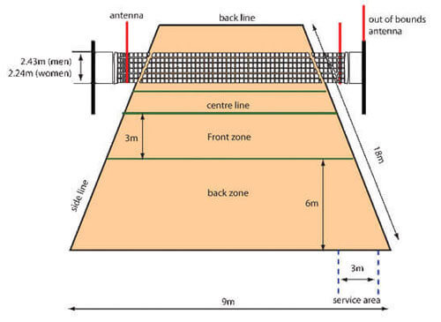

The Playing Positions
The six playing positions in a team on the Volleyball court are:

- the front-line players
- right front
- centre front
- left front
- the back-row players
- right back
- centre back
- left back

Questions for Topic

- What is Volleyball?
- How do you play Volleyball?
- How do you score in Volleyball?
- How long does it take to play Volleyball?
- Draw a labelled diagram of the Volleyball court.
- What is the height of the Volleyball net for men and women?
- List the six playing positions in a team on the Volleyball court.
- List the equipment used to play Volleyball?
- Who are the officials in a Volleyball game?
- What are the skills needed to play Volleyball?
- What are the benefits of volleyball?
- Explain the following rules of Volleyball?
- The serve
- Rotation
- Playing the game
- Basic Violations
- Give the definition of the following Volleyball terms.

- Ace
- Bump
- Dig
- Dink
- Double block
- Foul
- Held ball
- Jump serve
- Rotation
- Set
- Setter
- Side out

Equipment used to play Volleyball
- The ball
- uniform
- knee pads
- Appropriate footwear.
Skills needed to play Volleyball
- Serving
- Passing
- Spiking
- Blocking
Benefits of Volleyball
- Good physical workout
- Cultivation of teamwork
- Opportunity for bonding among team members
- Volleyball belongs to the category of games known as net games. It is similar to badminton and tennis.

