TYPES OF STAIRS COMMONLY DESIGNED FOR BUILDINGS

TYPES OF STAIRS
A stair is a series of steps arranged in such a manner as to connect different floors of a building. Stairs are designed to provide as easy and quick access to different floors. A staircase is an enclosure which contains the complete stairway.
Generally stairs are of following types
- Straight stairs
- Quarter turn stairs
- Half turn stairs
- Three quarter turn stairs
- Circular stairs
- Spiral stairs
- Curved stairs
- Geometric stairs
- Bifurcated stairs and
- Combination above types

All responses should be sent via email to swabyaudley@gmail.com

1. STRAIGHT STAIRS
These are the stairs along which there is no change in direction on any flight between two successive floors. The straight stairs can be of following types.
- Straight run with a single flight between floors
- Straight run with a series of flight without change in direction
- Parallel stairs
- Angle stairs
- Scissors stairs
Straight stairs can have a change in direction at an intermediate landing. In case of angle stairs, the successive flights are at an angle to each other. Scissor stairs are comprised of a pair of straight runs in opposite directions and are placed on opposite sides of a fire resistive wall.

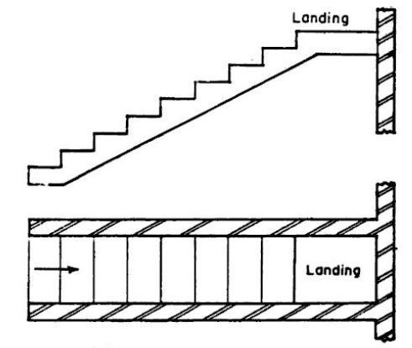

Straight Stair with Landing

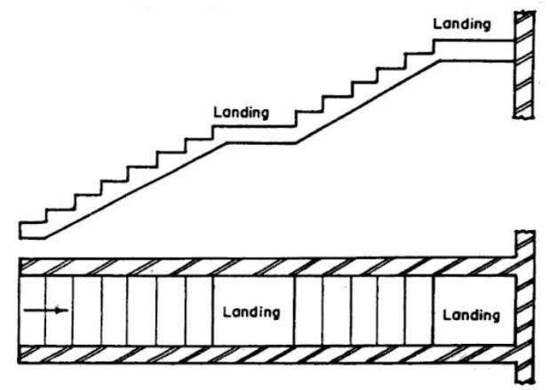
Straight Flight Stair with Two Landing

2. QUARTER TURN STAIRS
They are provided when the direction of flight is to be changed by 90⁰. The change in direction can be effected by either introducing a quarter space landing or by providing winders at the junctions.

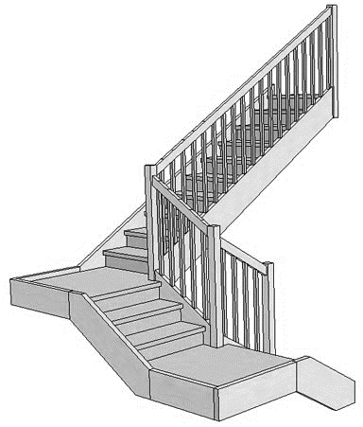Quarter Turn Stairs

3. HALF TURN STAIRS
These stairs change their direction through 180⁰. It can be either dog-legged or open newel type. In case of dog legged stairs the flights are in opposite directions and no space is provided between the flights in plan. On the other hand in open newel stairs, there is a well or opening between the flights and it may be used to accommodate a lift. These stairs are used at places where sufficient space is available.

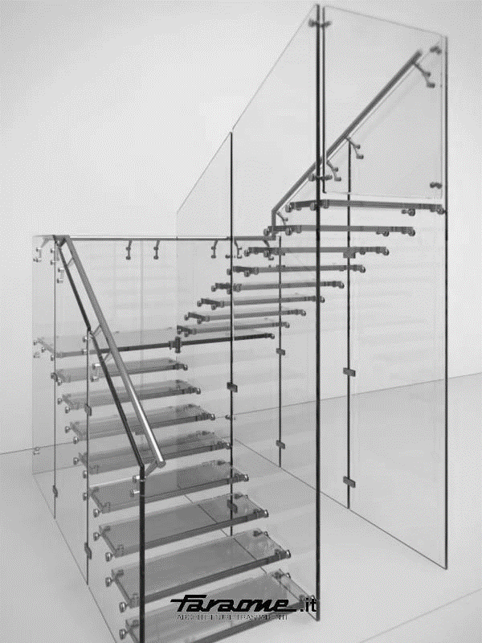

Half Turn Stairs
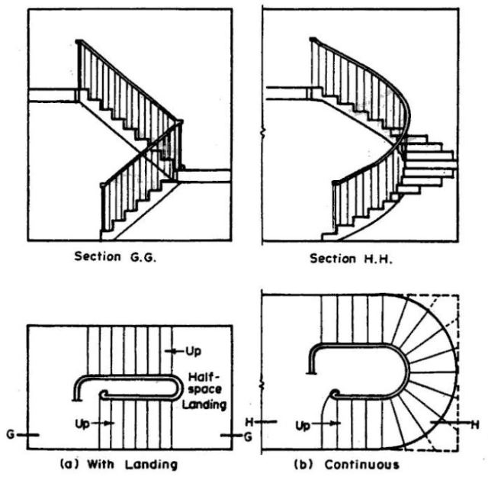

Half Turn Stairs

4. THREE QUARTER TURN STAIRS
These types of stairs change their directions through 270⁰. In other words direction is changed three times with its upper flight crossing the bottom one. In this type of construction an open well is formed.

5. CIRCULAR STAIRS
These stairs, when viewed from above, appear to follow circle with a single centre of curvature and large radius. These stairs are generally provided at the rear of a building to give access for servicing at various floors. All the steps radiate from a newel post in the form of winders. These stairs can be constructed in stone, cast iron or R.C.C.
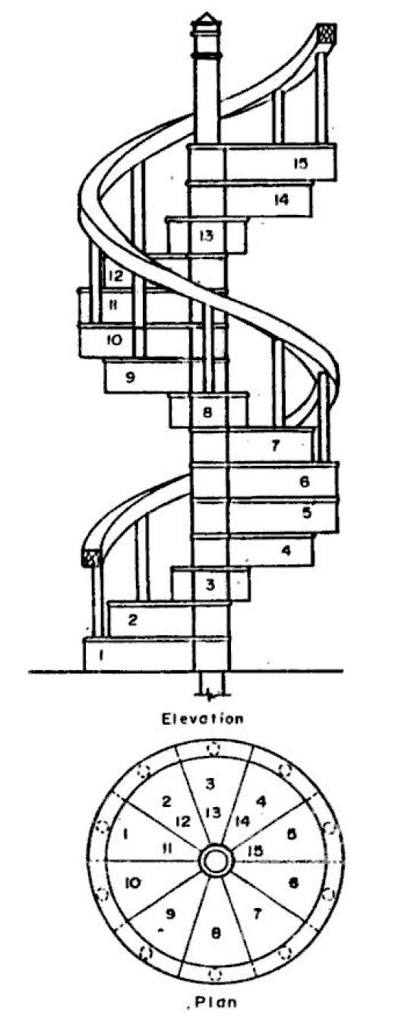

Spiral Stairs

6. SPIRAL STAIRS
These stairs are similar to circular stairs except that the radius of curvature is small and the stairs may be supported by a center post. Overall diameter of such stairs may range from 1 to 2.5 m.

7. CURVED STAIRS
These stairs, when viewed from above, appear to follow a curve with two or more centre of curvature, such as ellipse.

8. GEOMETRICAL STAIRS

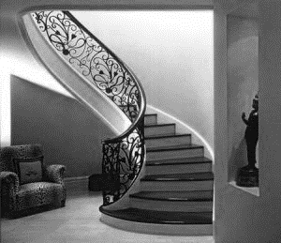

Half turn Geometrical Stair

These stairs have no newel post and are of any geometrical shape. The change in direction in these stairs is achieved through winders. The stairs require more skill for its construction and are weaker than open newel stairs. In these stairs the open well between the forward and the backward flights is curved.

9. BIFURCATED STAIRS
These stairs are so arranged that there is a wide flight at the start which is subdivided into narrow flights at the mid-landing. The two narrow flights start from either side of mid landing. Generally these stairs are more suitable for modern public buildings.
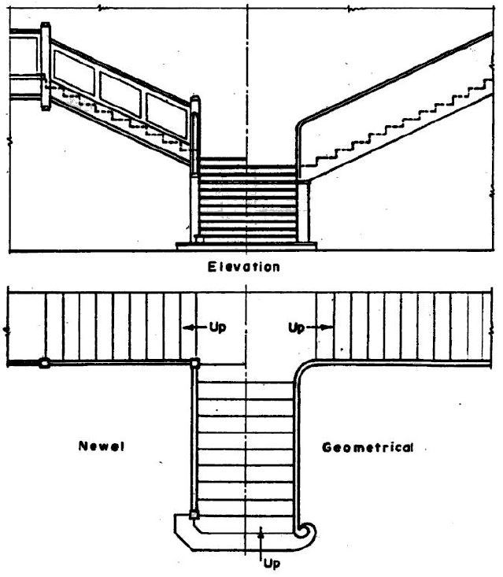

Staircase parts
Staircases may be all sorts sizes and arrangements (with or without landings etc.) to suit different properties but the main parts which go up to make any stair case are fairly common. A typical staircase is illustrated below with the main parts identified with more detailed definitions of each below.
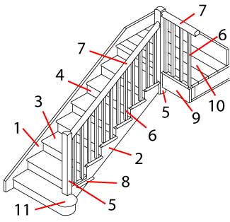
- Inner string (closed).  - Outer string (open).  - Tread.  - Riser.  - Newel post.  - Balusters. | - Banister (or handrail).  - Return nosing.  - Fascia.  - Landing.  - Curtail.
The main features of staircases have not changed over the years, although the style has changed - the newel posts and balusters were often more ornate on older staircases, later balusters were sometimes covered by a solid in-fill (older staircases which were updated often had the balusters covered with hardboard, removing this may reveal the original balusters).
The various parts for a staircase were traditionally made in a carpenter's workshop and then the staircase was built into the property as it was being built. Modern practice is for staircase parts (or complete simple staircases) to be mass produced so that the assembly on site is minimized.
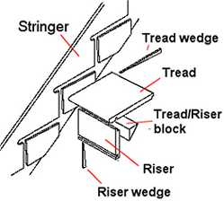

The traditional method (as right) for fixing the treads and risers to the stringers was to use wedges in slots in the stringers with the front of the treads and tops of the risers were secured to each other by glued blocks.
Modern, mass produced staircases tend to use glued blocks between both the treads/stringers and the treads/risers.
Definition of staircase parts

Balusters
The vertical posts in the space under the banister to the treads or floor (on the side of a landing).
Banister
The handrails up the side (or sides) of a stairway and, as an extension, along the edge of a landing.
Curtail step
The bottom step of a staircase which curves around sideways beyond the side of the staircase.
Fascia
The vertical covering under the edge of an exposed landing which covers the gap between ceiling and floor.
Finial
A decorative ornament used to decorate the top (and possibly the bottom) of a newel post - often in the shape of an ball, spike, urn, bun, or figure.
Half Landing
The flat area of flooring where a stairway makes a turn between main floors.
Inner (closed) string
The side of a staircase set against a wall which locates the treads and risers.
Landing
The flat area of flooring at the top and bottom of a staircase leading to rooms.
Newel post
The vertical post at the end or turn of a banister.
Outer (open) string
The side of a staircase open to view which locates the treads and risers.
Return nosing
The moulding, (normally half round) fixed to the ends of the treads exposed in a hallway and which covers where the balusters fit into the treads.
Riser
The vertical part of a step.
Riser wedges
The, usually wooden, wedges used vertically underneath a staircase in slots cut into the strings to secure the risers.
Tread
The horizontal part of a step.
Tread wedges

The, usually wooden, wedges used horizontal underneath a staircase in slots cut into the strings to secure the treads
.
Tread/riser blocks

The, usually wooden, blocks used by gluing to secure the front of the treads to the top of the risers at the front edge of each step.

Please Note: ALL information received will be tested on and grades forward to mark sheet.
Date for Test: 31. 3. 2020 (March 31, 2020)
Marking will be done April 6, 2020 – April 10, 2020

