Information Technology
Database Management
Grade 10

Objective 1: create a database

Use the following tables create the database called Motor Vehicle Registration.
VEHICLES
Vehicle Registration Number | Vehicle Type | Make | Registration Expiry Date | Taxpayer ID
A101 | Car | BMW | 09-Apr-13 | 1101
A107 | Car | Honda | 04-May-13 | 8808
A194 | Car | Audi | 29-May-13 | 4404
B101 | Car | Nissan | 23-Jun-13 | 7340
CC558 | Truck | Isuzu | 19-Jul-13 | 5569
CC788 | Truck | Mack | 12-Aug-13 | 1101
CC369 | Truck | Leyland | 09-Sep-13 | 8808
004B | Bike | Honda | 01-Oct-13 | 4404
104B | Bike | Kawasaki | 26-Oct-13 | 7340
904X | Bike | Jing | 20-Nov-13 | 5569
D692 | Car | Honda | 15-Dec-13 | 1101
E744 | Car | Audi | 09-Jan-14 | 8808
E221 | Car | Nissan | 03-Feb-14 | 4404
E207 | Car | Audi | 28-Feb-14 | 7340
X994 | Car | Nissan | 25-Mar-14 | 5569
G334 | Car | Toyota | 19-Apr-14 | 5569
F587 | Car | Toyota | 14-May-14 | 5569
G009 | Car | Isuzu | 08-Jun-14 | 1101
CC998 | Truck | Mack | 03-Jul-14 | 1101
CC008 | Truck | International | 28-Jul-14 | 1101

FEES
Vehicle Type | Registration Fee
Bike | 100.00
Car | 250.00
Truck | 500.00

OWNER
Taxpayer ID | First Name | Last Name | Government Employee | Gender | Address | Telephone Number
1101 | John | Black | Yes | M | 23 Cherry Street | (876)741-5252
8808 | Eve | Gray | No | F | 45 White waters | (876)941-5255
4404 | Joe | Green | No | M | 56 Orange Street | (876)851-5111
7340 | Winstona | Brown | No | F | 17 Waterloo Road | (876)941-4112
5569 | Bruce | White | Yes | M | 2 Portmouth Avenue | (876)547-9635

- Click on the Windows button/icon
- Search for Microsoft Office Access or Access 2013 and click on it
- Click on Blank Desktop Database
- Name the database as Motor Vehicle Registration (You may click on the folder icon beside the name and search for where you want the file to be saved, then click OK.)

- Click on Create
- Right click on Table1 and select Design View or click on View on the FILE menu bar and select Design View

- Rename the table and click OK
- Select the primary key for the first field if it is the unique key that will be used to identify each record.
- Write in the field name, select the appropriate data type and write a brief description
- Set the field size for the field based on the number of characters in the longest word in the column (field)
- Put in the Format. > is used to ensure that all letters in that field is CAPITALIZED

- Continue adding the other fields
- For vehicle type a set of values will be used, “Car”, “Truck”, “Bike”, therefore while on that field, click on LOOKUP, beside General tab. Change the Display Control to “List Box” by clicking on the drop down box, change Row Source type to “Value List” and in Row Source type in “Car”, “Truck”, “Bike”. This will allow you to have a drop down box in your database to select the option from.

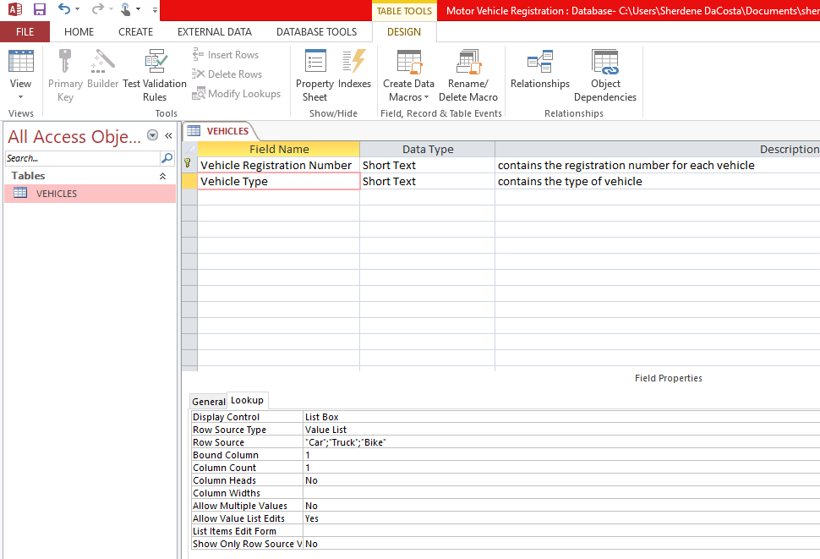

- For the field Registration Expiry Date, make the data type “Date/Time”. Look in the General Tab for FORMAT and click in the space beside it and then click on the drop down arrow and select Median Date

- Upon completing the first table, click on the X just above the description on the right side and click yes to save the field definitions.

To create the next table:
- Click on CREATE on the menu bar, select the TABLE icon
- Table1 will appear, click on it and then click on VIEW and select Deign View. Rename the table as FEES and click OK.
- Vehicle Type is unique as it does not repeat and it can be used to identify each record. Therefore set it as a Primary Key. Change the Data type and field size. Add the field description.
- Registration Fee is money and so the data type is currency. In the General tab, change decimal places to 2 instead of Auto.
- Close the field definition and save it.
- Repeat the steps to create a Table for OWNER. Put in the information for Taxpayer ID, First Name and Last Name. Government Employee data type is Yes/No

- For the Gender field, the field size will be 1 as you are only entering M or F
- On the General tab, the format for capital letter is set ( > ) and the validation Rule is added: “M” or “F” as well as the validation Text: "You can only enter M for Male and F for Female", The validation Rule is used to ensure that only those letters can be entered in the field. The validation text will appear on the screen if the user enters another letter other than M or F.
- Add the Address information, change the data type to text, field size to 30 and add the description
- Then add the Telephone Number (Because this field will not be used for calculations set it as TEXT). In the General Tab look for Input Mask and add: (876)999-9999. The 9s are just placeholder for the actual number. Instead of typing (876) every time to add a number, the input mask is set so that once the numbers are being typed in the area code comes up. The field size will be 13 as you count all the characters in the number.
- Save the OWNER table.
- To add or delete a field, right click on the table and select “Design View” or select it from the Menu bar.
- To Insert the field right click on the field that it must go before and select Insert Row. To delete row, right click on the row and select “Delete Row”

- Then close and save the table.

Populate each table with the information from the tables above.

- The above image shows what the Lookup Tab setting on Vehicle Type does, once you click on the field.
- The following images show the Vehicle table after it is populated with 20 records, the Fees table with 3 records and the Owner table with 5 records.

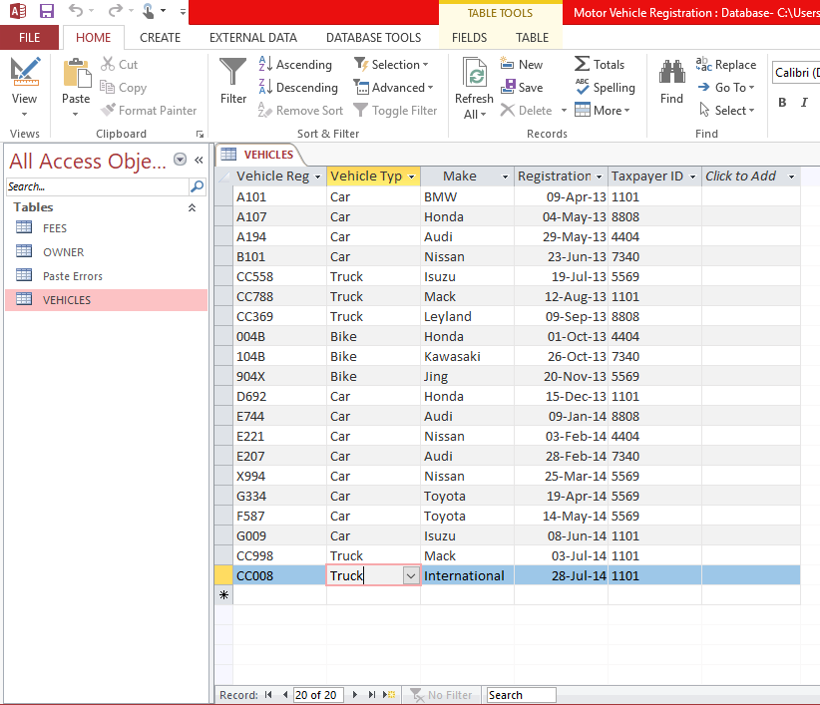

- The Input Mask is what allow the telephone Number field to have area code and the dash.

- To delete a record, right click on the row and select Delete Record.

- To sort a field in the table: Click on the arrow beside the field name and select the sort order (A to Z- ascending order or Z to A – descending order)

Establish relationships
[show the joins between tables (one-to-one and one-to-many).
- Close all Tables, right click on one of the table name and select Close All

- Click on Database Tools Tab on the menu bar, select the Relationships Icon. The show table dialogue box will appear, if it does not come up, click on the Show Table icon in the ribbon. To select all tables to add, click on the first one and hold down on the SHIFT button and click on the last one. Then click on ADD. Once the boxes come up, CLOSE the Show Table Dialogue box.

- The fields in the table that are common will be used to create the relationship, for example Vehicle Type in the FEES table match with Vehicle Type in the VEHICLES Table.
- Drag the Vehicle Type from the FEES table and release it on the Vehicle Type in the VEHICLES table. It was drag from the FEES table as in that table it is a primary key while in the VEHICLES Table it is a foreign key.
- The Edit Relationship Dialogue box will appear, click on the “Enforce Referential Integrity” check box. This ensures that whatever data you have in the Vehicle Type field in one table matches what you have in the Vehicle Type in the other table.

- Click Create
- The relationship link should be created. A 1 and ∞ shows that it is a One to Many relationship. (1:M). If for any reason this does not come up and an error message appears, close the relationship but do not save it and go to the tables and ensure that the word are spelt the same in both tables and there are no space before and after the names. In addition check if they are the same data type and the field definitions are the same. Then go back and try again.
- Once everything is good. Try linking the other common field, Taxpayer ID. Drag the Primary Key one to the Foreign Key one. And create the relationship.
- To edit or delete a relationship, right click on the line linking the table and select the appropriate option.
- Click the X and save the relationship.
Manipulate data in a database.

(a) Forms:[Use of form wizard only; select suitable fields; and, use of sub-form].
- On the Create tab, in the Forms group, click Form Wizard.
- Follow the directions on the pages of the Form Wizard.
Note: If you want to include fields from multiple tables and queries on the form, do not click Next or Finish after you select the fields from the first table or query on the first page of the Form Wizard. Instead, repeat the steps to select a table or query, and then click any additional fields that you want to include on the form. Then click Next or Finish to continue.
- Click on the > (add one at a time) or >> (add all fields one time) for the fields needed on the form. Add all of OWNER information. Then click on the last field that was sent over.
- Click on Table/Queries and select VEHICLES Table and send over everything except the Taxpayer ID as it was already taken from the OWNER table and it’s the primary key.
- Click NEXT
- Click on Form with subform and view data by OWNER. Then NEXT
- Choose how the subform must appear. Then NEXT
- On the last page of the wizard, click Finish after ensuring that the name is correct.
Below is the form after using the wizard to create it. It shows all the details for John Black.
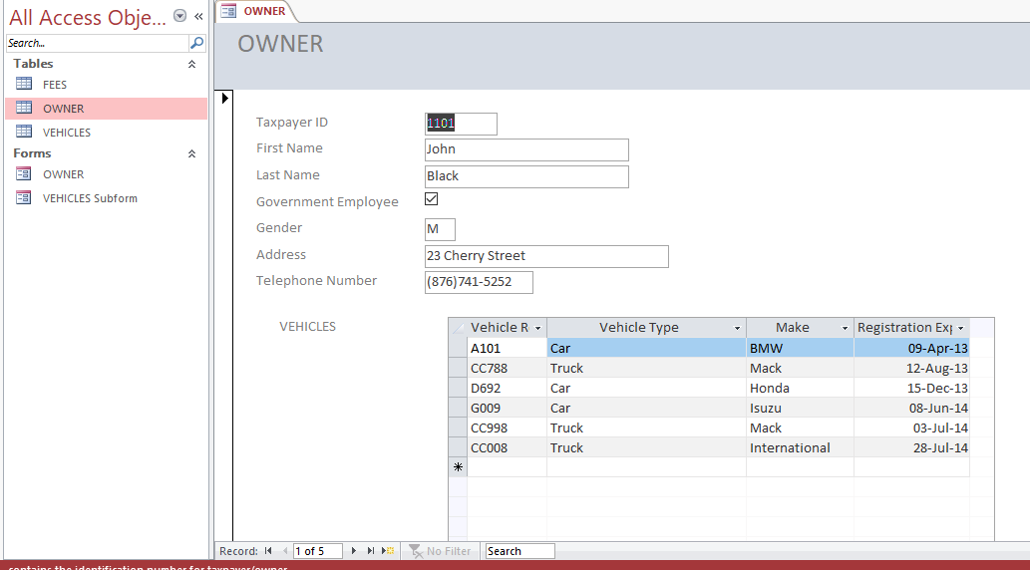
- Enter the following information on an OWNER and her vehicle in the form. Just click on the arrow beside Record at the bottom until you are at a blank form.
Taxpayer ID | 2202
First Name | Kerrian
Last Name | Reynolds
Government Employee | Yes
Gender | F
Address | 45 Berry Place
Telephone Number | (876)423-3333
Vehicle Registration Number | H100
Vehicle Type | Car
Make | Toyota
Registration Expiry Date | 21-Aug-14

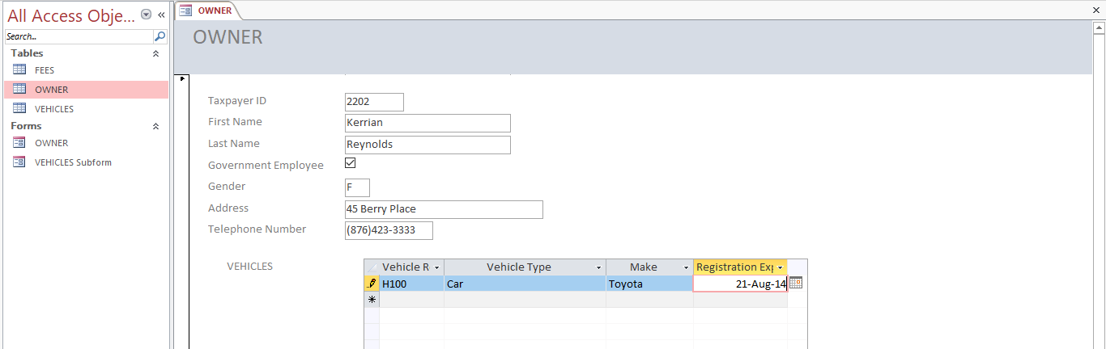
- Once you close the form and open the OWNER and VEHICLE Tables you should see the new data.

- Close all tables and save the changes.
(b) Queries: [more than one criterion; use of select; use of calculated field; and, two or more fields involving the use of relational and logical operators]

The following queries will be completed
1. List the name of the owner of the vehicle with registration number 904X
Steps:
- Click on the CREATE tab on the menu bar and select QUERY DESIGN
- Select the OWNER and VEHICLES Tables on the Show Table dialogue box and then select Add and then select close.
- Double click on all the field needed: Taxpayer ID, First Name, Last Name from OWNER Table, Vehicle Registration Number, Vehicle Type and Make. They will appear in the section labelled Field and Table at the Bottom.
- Under Vehicle Registration Number, in the row called CRITERIA “904X” must be typed in so that the computer knows that it should search for the name of the owner for that vehicle. Then select RUN icon (!), to the top left of the screen. If it is not showing look to the extreme top in the middle for “QUERY TOOLS” and click on it and look for the RUN icon.

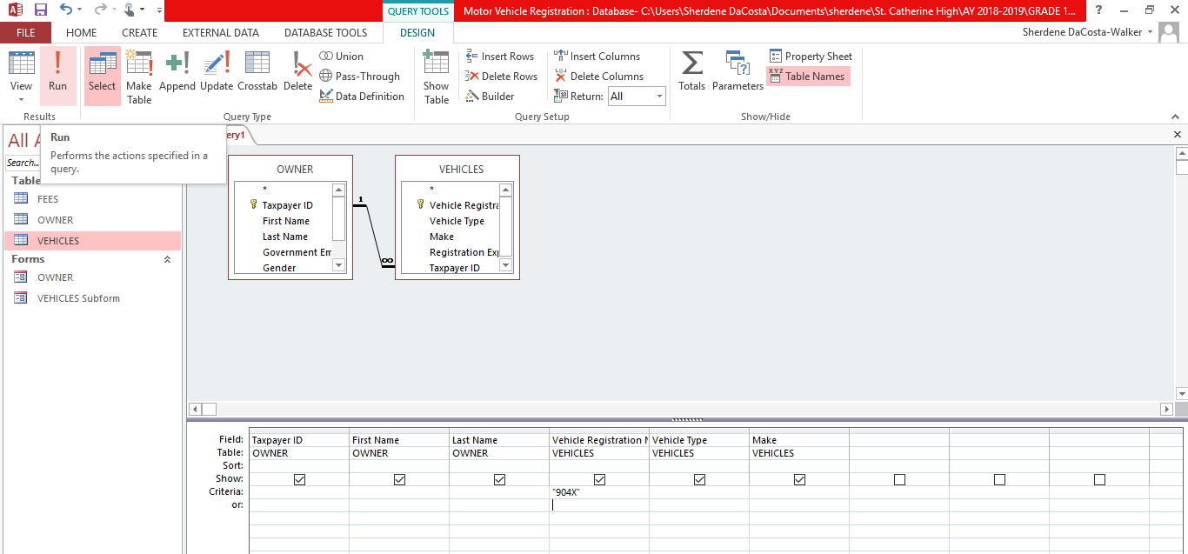
The following DATASHEET should come up. To go back into the Design View to make any adjust click on the VIEW icon and select DESIGN VIEW. Otherwise press X and save the query as “904X”

2. Vehicles Make starting with the letter “J” or ending with the letter “a”
- Follow the same procedure to create the query, add only the Vehicle table as no other data is needed from the other tables. Add all fields. Because the criteria is for the Make that where it will be written. It requires two criteria, the first in the criteria row and the other in the OR row. To prevent a field from showing even though it was selected, unclick the box in the SHOW row and that field will not appear in the Datasheet after the query runs. Then Run the query.

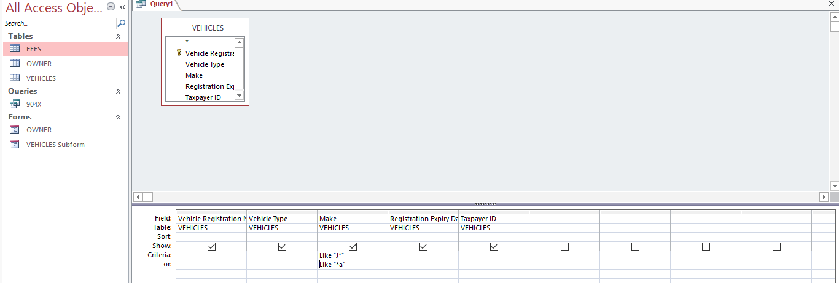
- Only Vehicle with Make starting with “J” and ending with “a” appear on the datasheet. Save as J AND A.

3. List the total registration fees to be paid by John Black when his current registration expires.
STEPS:
- Follow the previous steps to create a query and add all the tables needed and fields. Then enter the criteria “ John” or “Black” under the relevant field(s). Then run the query.

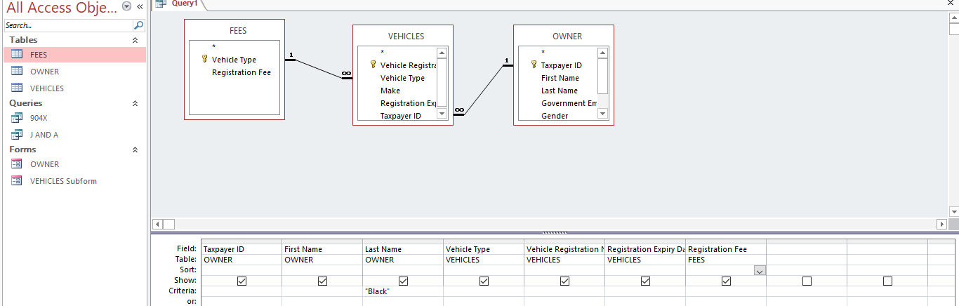
- On the HOME tab above the record group, select the summation (Σ) symbol then Total will appear. In the row of the total click under the Registration fee and select sum. Save query as Sum of John Black fee

- Another method was to follow the first step and then save the query. Then create a new query and when the SHOW Table dialogue box comes up click on the Queries tab and select the query that was saved. Add that query and close the dialogue box.

- Add only the registration fee field. Then click on the summation symbol, under the Show/Hide group. A row with the title “Totals” will appear below the table name and the word “Group by” will be in the row. Click on the drop down arrow beside the words and select Sum. Then run the query.

Calculated Query
4. The government of the country has decided that they need to check how much each fee would be if they added 25% to each. Show the original figure
- Follow the steps in creating a query and add the FEES Table.
- Add all the fields
- In a blank column beside the last field add, type the calculation or go to the Query Setup group and select “BUILDER” and type the information. New Registration Fee: [Registration Fee] + ([Registration Fee] * 0.25)

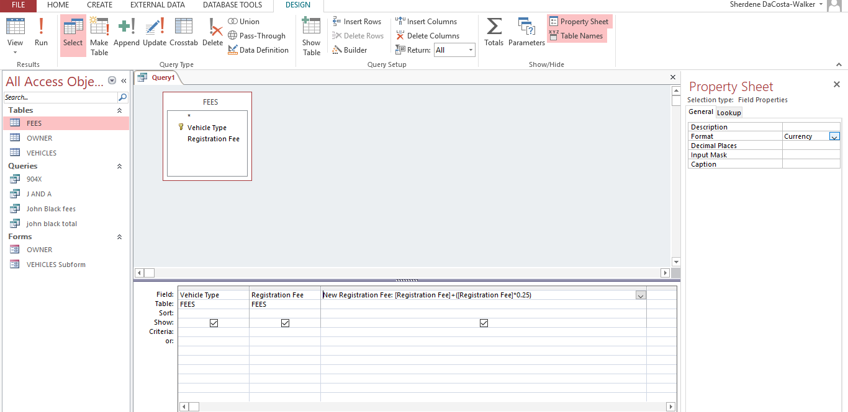
- Before the query RUN, go to the “Property Sheet” and change “Format” to currency. Decimal place: 2. Then RUN. Save as 25% increase

Other Examples of calculated query field: Due Date: [Invoice Date] +60 (Adding 60 days to invoice date) or Stay: [Departure Date]- [Arrival Date] (To calculate the number of days between two dates)

UPDATE OR DELETE QUERIES
Update Bike Registration fee to $120.00 from $100.00
- Click CREATE on the menu bar and select query design.
- Select and add the Fees Table and then close the Show Table dialogue box
- Look in the Query Type group in Query Tools and Select Update
- Put in the criteria “Bike” under Vehicle type and in the Update to row under Registration fee, put 120
- Click Run ( ! ) and a dialogue box will appear to ascertain if you really want to Update the data. Select “Yes”. Nothing visual will happen, so save the update query and close it. Open the FEES table, the figure will be changed. Do not press on the update query again as it will continue to update the data. To view the query, right click and select “Design View.”
- Delete Query works similarly. Instead of selecting Update under the query type group, select delete
- Add the criteria and what should be deleted.

- Just like the update once you click the delete query more than once it will change the data in the table.

Other practice queries
- List the vehicles owned by the persons with taxpayer id=5569
- List the name of all truck drivers
- List all vehicles that are not trucks that are owned by government employees.
- List all vehicle information of all vehicles that will expire the second half of 2014.
- List fee(s) greater than 250.00

(c) Reports:
- Click on the CREATE Tab, under the report group select “Report Wizard”
- When the dialogue box appears, select the Owner, Vehicles and Fees tables
- Add all the fields seen in the right image above from the three tables and then click “Next”
- Select how to view the data “By OWNER” Then select “Next”
- In the right image above, using the ( > ) button send over the Taxpayer ID to use to group the data. It should look like the left image below. Then select “Next” Select “Vehicle Registration Number” to sort the data in ascending order. Finally, select the “Summary Option” button.

- Select all the options in the “Summary Options” and click “OK”. Then “Next”.
- Select the Layout “Stepped” and “Landscape” then click “Next”

- Rename the report and click “Finish”

- Close the “Report Preview” and adjust the presentation of the data. Drag the labels over so that they appear neater and closer, so that all data can hold. Once you move the headings in the header, the details must also be adjusted so that they are inline.
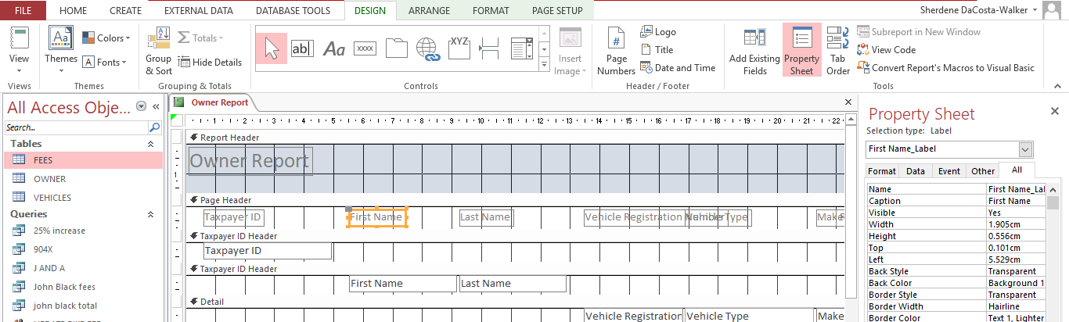
.
.
- Click on the title “Owner Report” and edit it to “Motor Regristration Report”. It can move to the center by dragging it across. To get two titles, right click on the first title and copy. Then right at the page header, put it down to widen the space and then paste the second heading. You can then rename it.

- Under Report Design Tools, select DESIGN and Click “View” and select Report View

