Resistor Colour Codes
Chapter 2 - Colour Codes
PDF Version
Try out our Resistor Colour Code Calculator in our Tools section.
Standard Resistor Values and Colour
Components and wires are coded with colours to identify their value and function. Resistor Colour Coding uses coloured bands to quickly identify a resistors resistive value and its percentage of tolerance with the physical size of the resistor indicating its wattage rating.
Generally, the resistance value, tolerance, and wattage rating are printed on the body of a resistor as numbers or letters when the resistors body is big enough to read the print, such as large power resistors. But when a resistor is smaller (example: 1/4-watt carbon or film type), the print is too small to read, so the specifications must be shown in another way.

Colour | Digit | Multiplier | Tolerance (%)
Black | 0 | 10⁰(1)
Brown | 1 | 10¹ | 1
Red | 2 | 10² | 2
Orange | 3 | 10³
Yellow | 4 | 10⁴
Green | 5 | 10⁵ | 0.5
Blue | 6 | 10⁶ | 0.25
Violet | 7 | 10⁷ | 0.1
Grey | 8 | 10⁸
White | 9 | 10⁹
Gold |  | 10⁻¹ | 5
Silver |  | 10⁻² | 10
(none) |  |  | 20

The colours brown, red, green, blue, and violet are used as tolerance codes on 5-band resistors only. All 5-band resistors use a coloured tolerance band. The blank (20%) “band” is only used with the “4-band” code (3 coloured bands + a blank “band”).

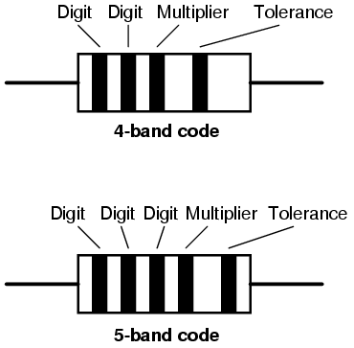

Yellow-Violet-Orange-Gold Colour Code

A resistor coloured Yellow-Violet-Orange-Gold would be 47 kΩ with a tolerance of +/- 5%.

Green-Red-Gold-Silver Colour Code

A resistor coloured Green-Red-Gold-Silver would be 5.2 Ω with a tolerance of +/- 10%.

White-Violet-Black Colour Code

A resistor coloured White-Violet-Black would be 97 Ω with a tolerance of +/- 20%. When you see only three colour bands on a resistor, you know that it is actually a 4-band code with a blank (20%) tolerance band.

Orange-Orange-Black-Brown-Violet Colour Code

A resistor coloured Orange-Orange-Black-Brown-Violet would be 3.3 kΩ with a tolerance of +/- 0.1%.

Brown-Green-Grey-Silver-Red Colour Code

A resistor coloured Brown-Green-Grey-Silver-Red would be 1.58 Ω with a tolerance of +/- 2%.

Blue-Brown-Green-Silver-Blue Colour Code

A resistor coloured Blue-Brown-Green-Silver-Blue would be 6.15 Ω with a tolerance of +/- 0.25%.

How does the resistor colour code work?
Resistor values are often indicated with colour codes. Practically all leaded resistors with a power rating up to one watt are marked with colour bands. The coding is defined in the international standard IEC 60062. This standard describes the marking codes for resistors and capacitors. It includes also numerical codes, as for example often used for SMD resistors. The colour code is given by several bands. Together they specify the resistance value, the tolerance and sometimes the reliability or failure rate. The number of bands varies from three till six. As a minimum, two bands indicate the resistance value and one band serves as multiplier. The resistance values are standardized, these values are called preferred value.
Resistor colour code chart
The chart below shows how to determine the resistance and tolerance for resistors. The table can also be used to specify the colour of the bands when the values are known. An automatic resistor calculator can be used to quickly find the resistor values.
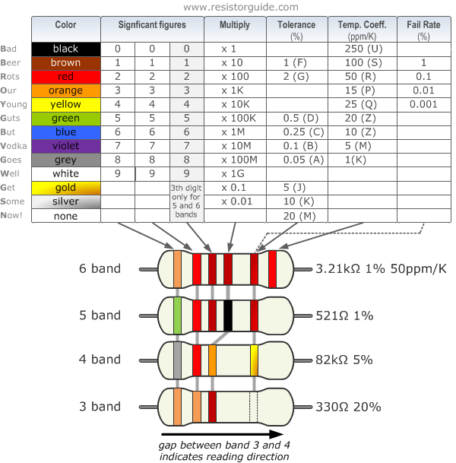
Tips for reading resistor codes
In the sections below examples are given for different numbers of bands, but first some tips are given to read the colour code:
- The reading direction might not always be clear. Sometimes the increased space between band 3 and 4 give away the reading direction. Also, the first band is usually the closest to a lead. A gold or silver band (the tolerance) is always the last band.
- It is a good practice to check the manufacturer’s documentation to be sure about the used coding system. Even better is to measure the resistance with a multi-meter. In some cases, this might even be the only way to figure out the resistance; for example, when the colour bands are burnt off.
4 band resistor
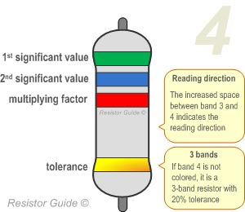 | The four band colour code is the most common variation. These resistors have two bands for the resistance value, one multiplier and one tolerance band. In the example on the left these bands are green, blue, red and gold. By using the colour code chart, one finds that green stands for 5 and blue for 6. The value is thus 56·100 =5600 Ω. The golden band means that the resistor has a tolerance of 5%. The resistance value lies therefore between 5320 and 5880 Ω.  If the tolerance band would be left blank, the result is a 3 band resistor. This means that the resistance value remains the same, but the tolerance is 20%.
5 band resistor
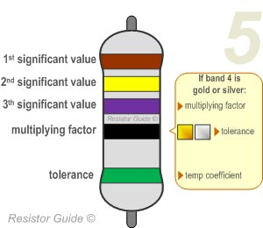 | Resistors with high precision have an extra band to indicate a third significant digit. Therefore, the first three bands indicate the significant digits, the fourth band is the multiply factor and the fifth band represents the tolerance. There are exceptions to this. For example, sometimes the extra band indicates failure rate (military specification) or temperature coefficient (older or specialized resistors). Please read the section “Colour code exceptions” for more information.  Shown example: brown (1), yellow (4), purple (7), black (x1), green (0.5%): 147 Ω 0.5%.
6 band resistor
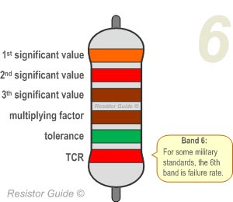 | Resistors with 6 bands are usually for high precision resistors that have an additional band to specify the temperature coefficient (ppm/K). The most common colour for the sixth band is brown (100 ppm/K). This means that for a temperature change of 10 ˚C, the resistance value can change 0.1%. For special applications where temperature coefficient is critical other colours  Shown example: orange (3), red (2), brown (1), green (x10), brown (1%), red(50 ppm/K): 3.21 k Ω 1% 50 ppm/K.
Read more http://www.resistorguide.com/resistor-color-code/

