Physical Education

Grade 10

Respiratory System

What Is the Respiratory System?
The respiratory system is the organs and other parts of your body involved in breathing, when you exchange oxygen and carbon dioxide.

Parts of the Respiratory System
Your respiratory system includes your:
- Nose and nasal cavity
- Sinuses
- Mouth
- Throat (pharynx)
- Voice box (larynx)
- Windpipe (trachea)
- Diaphragm
- Lungs
- Bronchial tubes/bronchi
- Bronchioles
- Air sacs (alveoli)
- Capillaries

How Do We Breathe?
Breathing starts when you inhale air into your nose or mouth. It travels down the back of your throat and into your windpipe, which is divided into air passages called bronchial tubes.
For your lungs to perform their best, these airways need to be open. They should be free from inflammation or swelling and extra mucus.
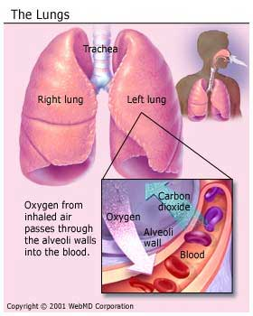
As the bronchial tubes pass through your lungs, they divide into smaller air passages called bronchioles. The bronchioles end in tiny balloon-like air sacs called alveoli. Your body has about 600 million alveoli.
The alveoli are surrounded by a mesh of tiny blood vessels called capillaries. Here, oxygen from inhaled air passes into your blood.
After absorbing oxygen, blood goes to your heart. Your heart then pumps it through your body to the cells of your tissues and organs.
As the cells use the oxygen, they make carbon dioxide that goes into your blood. Your blood then carries the carbon dioxide back to your lungs, where it’s removed from your body when you exhale.

Inhalation and Exhalation
Inhalation and exhalation are how your body brings in oxygen and gets rid of carbon dioxide. The process gets help from a large dome-shaped muscle under your lungs called the diaphragm.
When you breathe in, your diaphragm pulls downward, creating a vacuum that causes a rush of air into your lungs.
The opposite happens with exhalation: Your diaphragm relaxes upward, pushing on your lungs, allowing them to deflate.

