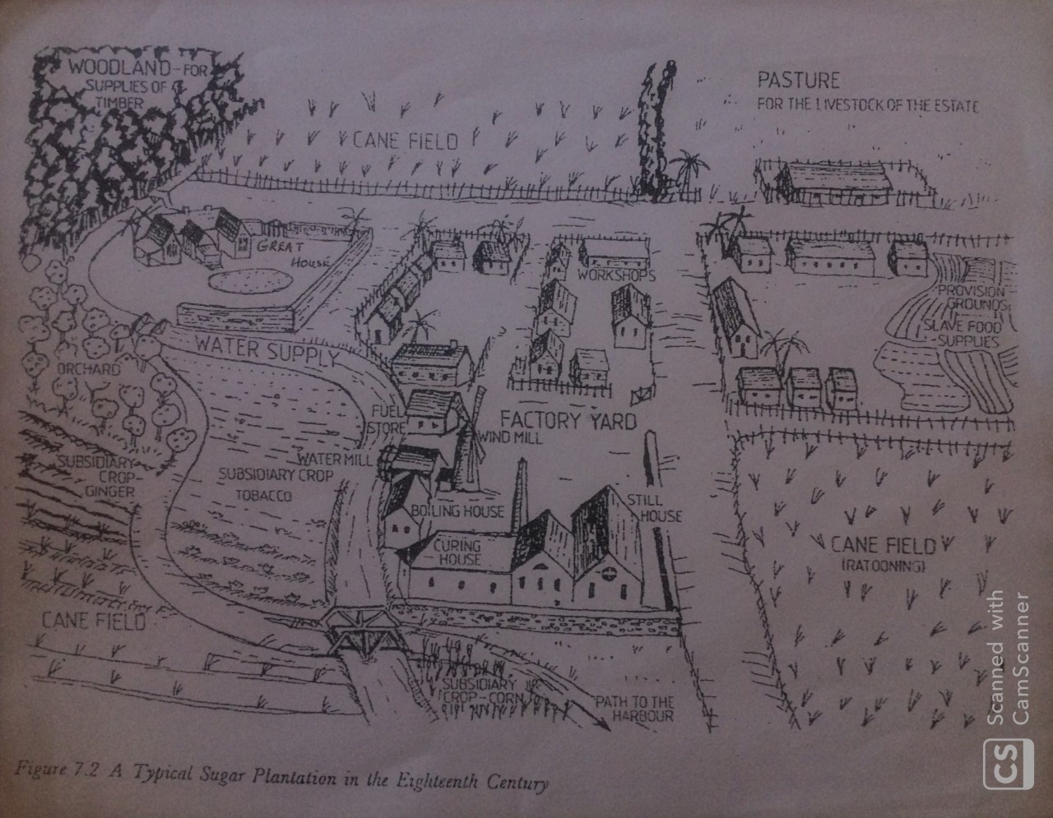
- Using the diagram of the plantation as a guide highlight the following areas: cane fields, great house, slave huts, distillery, provision grounds.
- Describe at least three uses for the timber that was taken from the woodland.

